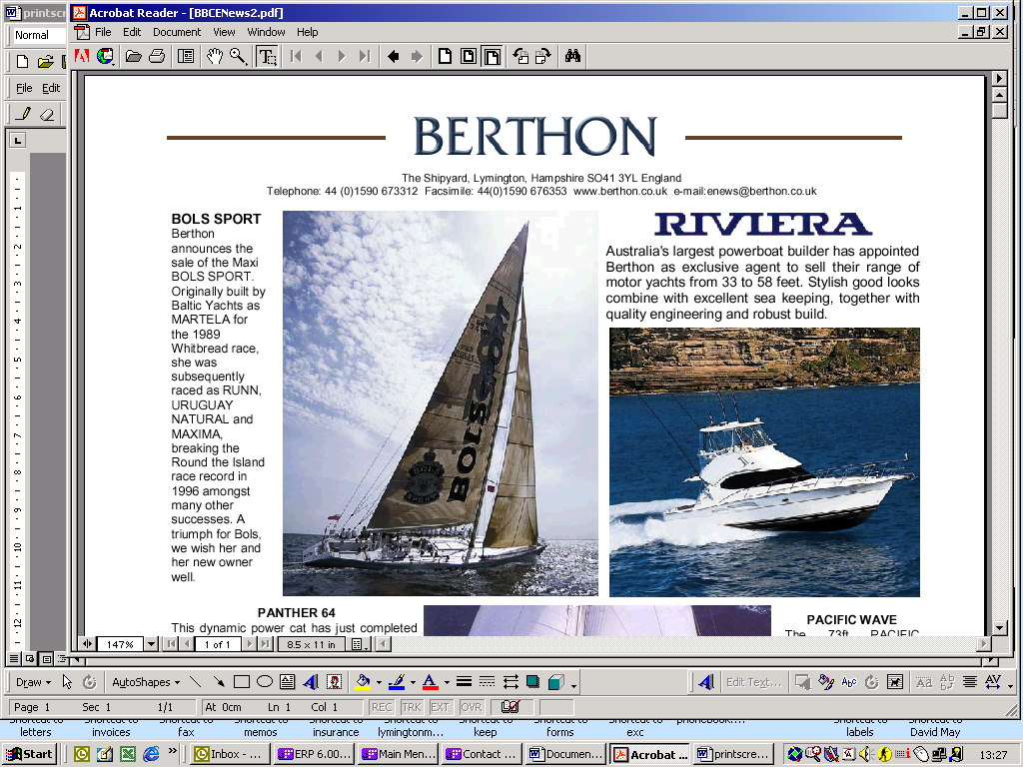

Berthon Boat Company Limited, The Shipyard, Lymington, Hampshire SO41 3YL England

Telephone: 44 (0) 1590 673312 Facsimile: 44 (0) 1590 647446 www.berthon.co.uk e-mail: refits@berthon.co.uk

**Berthon Boat Co Ltd Terms of Business**

These Terms of Business are, unless otherwise agreed in writing, applicable to and form part of all agreements for Our Work to be carried out by Berthon Boat Co Ltd and should be read in conjunction with and form an integral part of any estimate, specification or other contractual documents. Acceptance by the Owner of any offer to perform Work whether in writing or verbally or by earlier commencement of Our Work shall be deemed to be an acceptance of these Terms. The Owner shall procure that its agents, employees and contractors are bound by the Terms insofar as applicable to them.

**Definitions**

The following definitions shall apply:

"We", "Us", "Our" means Berthon Boat Co Ltd and Our employees.

"Completion of Work" has the meaning set out in clause 1.4.

"Length Overall" or "LOA" means the length of the Vessel, including all extensions such as tenders, dinghies in davits, bowsprits, bumpkins, anchors, pulpits, bathing platforms etc. Fractions of a foot measuring below 6” will be rounded down to the nearest whole foot and fractions of a foot measuring 6” and above will be rounded up to the nearest whole foot.

"Marina" means Lymington Marina Limited and its premises.

"Marina Terms" means the Marina’s published standard terms and conditions as amended from time to time.

"Owner" means the person or entity that Owns the Vessel and instructs us pursuant to do Work subject to these Terms.

"Owner's Contractors" means those persons engaged for and on behalf of the Owner pursuant to clause 3.1 (a) below.

"Owner's Supply Items" means those items supplied by the Owner or such other third parties.

"Party" means each the Owner and Us and together "Parties".

"Premises" means Our Premises at the Shipyard and Marina, Lymington, SO413YL.

"Terms" means these Terms of Business.

"Vessel" means the boat or other item on which We perform Our Work and includes without limitation the Vessel's tenders and appurtenances together with all items normally onboard.

"Warranty Work" has the meaning in clause 8.1.

"Warranty Period" has the meaning in clause 8.2.

"Work" includes any and all Work goods supplied and services performed by Us as further defined in clause 2.1.

"You" or "Your" is a reference to You as the Owner and as applicable Your crew or contractors.

1. **Performance of Our Work**

* 1. We will complete Our Work in accordance with the agreed specification and, in the absence of any other contractual term as to quality, to a satisfactory quality.
  2. The time for completion of Work is given in good faith but is an estimate only and is not guaranteed.
  3. The Owner acknowledges that it has not and will not rely on any verbal representation.
  4. Completion of Our Work is deemed to occur on the date that a particular job is finished and tested by Us or the date on which Our services are terminated sooner for any other reason whatsoever, whichever is sooner.
  5. If the person or entity instructing us to perform Work is not the Owner of the Vessel, they are nonetheless bound by these Terms, including the obligations under clause 5, as if they were the Owner and shall procure that the person or entity that owns the Vessel is bound by the limitations, exclusions and obligations set out in these Terms.

1. **Liability**
   1. The scope of Work to be undertaken and/or material or equipment to be supplied by Us is set out exclusively in the estimate, specification and invoice.
   2. In the performance of such Work and any other Work undertaken by Us including Warranty Work, We and Our employees:
   3. accept no responsibility for any loss, damage or delay, arising from any cause whatsoever unless caused by or resulting from Our negligence or wilful default;
   4. have no obligation to detect and/or remedy any other defects, damage or problems with the Vessel whatsoever whether they be latent or patent;
   5. if and to the extent that Our Work is based on instructions, drawings or designs supplied by the Owner or any third party, Our sole obligation will be to perform Our Work and the supply of goods and equipment in accordance with such instructions/drawings/designs as supplied and/or the recommendations of such third party;
   6. when dismantling or removing any materials, parts or equipment We will use reasonable endeavours to prevent breakages and damage but in the nature of such Work We accept no liability whatsoever for any damage which might occur thereby;
   7. accept no liability for damage or defects which become apparent on or after re-assembly by Us of materials, parts or equipment dismantled or removed by others;
   8. accept no liability whatsoever for Owner's supply Items, whether or not installed by Us, and for which the Owner is solely responsible for ensuring that such goods or equipment are of satisfactory quality and suitable for the intended purpose;
   9. accept no liability whether in contract or tort to any other party than the Owner (save and in so far as clause 1.5 provides) and shall have no liability for Work carried out for, or invoiced to, or paid for by someone else including without limitation any subsequent purchaser of the Vessel;
   10. for Work carried out for, or invoiced to, or paid for by someone else including without limitation any subsequent purchaser of the Vessel;
   11. accept no liability for any loss, damage or delay, caused by or contributed to as a result of the Owner's breaches of their obligations under these Terms including without limitation clauses 4 and 7;
   12. shall not be under any liability whatsoever to the Owner or any other party for any loss, damage or expense, resulting from any tests or trials or any movements of the Vessel when in the water, which shall be undertaken at the Owner’s sole risk and responsibility.
   13. Where We supply goods or services to an Owner in the course of his business no article supplied by Us shall carry any express or implied warranty as to its quality or its fitness for any particular purpose.
   14. In connection with the performance of Our Work, the following liabilities howsoever caused, are excluded under the warranty or otherwise:
2. indirect and consequential losses;
3. economic losses, including but not limited to loss of profit, income including charter income; and
4. any claim for loss of use and enjoyment.
   1. In the case of any defective workmanship caused by Our negligence or wilful default We accept no liability for loss, damage, cost or expense of whatever nature beyond the reasonable cost of Our rectifying the defective workmanship and Our replacing any defective materials or equipment supplied by Us.
   2. Nothing in this clause shall exclude or limit liability for:
5. death or personal injury caused by negligence;
6. fraud or fraudulent misrepresentation;
7. in the case of a consumer, breach of the terms implied by sections 9, 10, 11, 13 and 49 of the Consumer Rights Act 2015 (satisfactory quality, fitness for purpose, description, and reasonable care and skill); and
8. any other liability that cannot be excluded or limited under English law.
   1. Nothing herein contained shall affect any right We may have to limit Our liability under any statutory enactment for the time being in force.
   2. The Parties agree that the limitations and exclusions in this clause are reasonable in light of the nature of Work, the contract price, and the availability of insurance.
9. **Work on the Vessel otherwise than by Berthon** **Boat Co Ltd**
   1. The following provisions shall apply to all work of whatever nature required to be carried out by persons other than Us:
10. To the extent that work of any nature cannot be carried out by Us, We or the Owner may appoint a suitable sub-contractor hereinafter referred to as the Owner's Contractor. At Our absolute discretion such sub-contractor may then be contracted by the Owner, or by Us on the Owner’s behalf. In which case the cost of the Owner's Contractor may be invoiced to the Owner by Us in the same manner as Our other services save that (i) We shall have no responsibility whatsoever for the services provided by the Owner's Contractor; and (ii) We shall have no liability for or give no warranty for, without limitation, the Owner's Contractor’s advice, recommendations, work and/or materials it supplies; and
11. The Owner's Contractor shall only be allowed access to Our Premises if it has adequate public liability and third-party liability insurance, and evidence of such valid insurance must be provided before starting work.
    1. Notwithstanding the foregoing and subject to clauses 4 and 5, You and Your crew may carry out minor running repairs and minor maintenance work of a routine nature provided such works do not interfere with the performance of Our Work.
12. **Owner's responsibilities**
    1. In connection with the performance of Our Works:
13. The Owner shall provide Us with complete and accurate information about the Vessel or its parts and equipment and/or details of any relevant information that may be relevant to Our performance of Our Work, including without limitation any technical drawings or specifications and relevant maintenance history and incident records.
14. The Owner and its crew shall provide all reasonable assistance to Us and provide information or instructions when requested timeously;
15. The Owner warrants that if it provides a cradle support or trailer for storage of the Vessel that it is in satisfactory condition and suitable for supporting the Vessel or other equipment;
16. The Owner warrants that, whilst at Our Premises or being worked on by Us, the Vessel and/or their property is adequately insured (with insurers being duly notified of work if required) against all risks, and that the Owner and crew are adequately insured against third party liabilities in case the Vessel, the Owner, or the crew cause loss or damage whilst on Our Premises. The Owner shall forthwith upon request provide Us with a copy of such insurance policies;
17. All Vessels and gear are repaired, worked on, moved, stored or otherwise managed and kept at the sole risk of the Owner; and
18. The Owner shall and shall procure that his crew comply with all applicable laws, by-laws and regulations when using Our Premises.
    1. Insofar as You as the Owner including Your crew have any dealings with the Marina or make use of or benefit from the Marina’s premises or services including any storage of the Vessel ashore, You acknowledge that:
19. such dealings will be on the basis of the Marina’s Terms and in respect of such dealings You agree to contract also with the Marina and to be bound by those terms and conditions to the extent that they are not inconsistent with these Terms;
20. All access and contracting arrangements are operated in a manner that is compliant with applicable Health & Safety and Control of Substances Hazardous to Health (COSHH) regulations. Owners will be charged for any breach of COSHH and/or Health & Safety; and
21. All persons entering upon or using any part of Our Premises, facilities or equipment do so at their own risk. Owners’ and crew cars must be parked in the Marina car park, and not in the boatyard. We will accept no responsibility for any damage howsoever caused to cars parked in the boatyard or elsewhere on Our Premises, or any other property belonging to the Owner or crew.
    1. Further, the Owner and crew shall:
22. provide their own hoses for filling water tanks, preferably of the lay-flat type and acknowledge that hoses supplied by Us are not intended for drinking water and will adequately flush all hose union taps and hoses used to fill tanks for drinking water prior to use. Use of hoses supplied by Us is at the Owner’s own risk as We are unable to guarantee hoses supplied by Us have not been contaminated by a previous user;
23. only use private pressure washers that are of the type which includes an integral break cistern and air gap providing fluid category five backflow protection; and
24. place waste and refuse in the appropriate receptacles provided (including absolute adherence to recyclables such as glass, plastics, cans, cardboard, metal) and not throw it overboard or leave it on pontoons or on Our Premises. Waste oil should be placed only in the waste oil tank; other large items and hazardous waste such as contaminated bilge water etc. should be reported to the dockmasters or to one of Our managers for appropriate discharge and subsequent cleaning.
    1. The Owner shall be responsible for ensuring compliance with all applicable customs tax and regulatory requirements relating to the Vessel including upon its arrival at, stay within, and departure from Our Premises. This includes the payment of any third-party charges duties or taxes particularly where an exemption from VAT is sought by the Owner. If at any time the Vessel is deemed liable for customs duties or VAT the Owner shall bear sole responsibility for such payments. Without prejudice to Our rights under Clause 5 We reserve the right to recover from the Owner any such amounts paid by Us on the Owner’s behalf together with any associated costs penalties or fines incurred by Us as a result of the Owner's breach of this provision.
    2. Unless otherwise agreed, upon Completion of Our Work, the Owner is responsible for removing the Vessel at their cost and risk from Our Premises, always subject to the Parties' rights and obligations particularly under clause 7. If the Vessel is not removed We reserve the right to charge for berthing or storage at Our daily rate based on the Vessel's LOA without waiver of Our rights under clauses 7 and 10.
25. **Indemnity**
    1. The Owner will indemnify and hold Us harmless in the event of any third party bringing a claim against Us that would impose a liability that is excluded or limited under these Terms.
    2. The Owner will further indemnify and hold Us harmless from any and all consequences of any breach of the Owner's obligations hereunder and the Owner hereby waives any right to limit its liability under any applicable law or convention in the event of such breach.
26. **Prices and Estimates**
    1. In the absence of express agreement to the contrary Our price for Work shall be based on the time and materials actually expended on or used in connection with the Work at Our then current hourly rate or price. Unless otherwise indicated all prices are estimates and exclude VAT. We will exercise reasonable skill and judgment in preparing estimates but estimates are not binding and do not represent fixed prices.
    2. Estimates are subject always to the accuracy of information provided by the Owner and are usually based only on a superficial examination, unless We are requested to carry out any necessary opening up or dismantling. Estimates do not include the cost of any emergent Work additional repairs or Work found necessary to the Vessel and/or gear or equipment during the Work nor the cost of any extensions to the Work specified in an estimate.
    3. We are not precluded from exceeding an estimate where necessary for the performance of the Work and We are not bound to inform the Owner of any cost increase while Work is ongoing. If We inform the Owner of any increase in costs the Owner will have the right to cancel the element of Work to which the proposed increase relates. In those circumstances, the Owner’s liability for any Work already completed and/or part-completed/to be completed or goods already supplied and/or ordered or to be supplied, shall be unaffected.
27. **Payment**
    1. Unless otherwise agreed in writing the price of all Work goods and services including storage ashore shall be due immediately on the date of invoice or, if earlier, prior to the departure from Our Premises of the Vessel to which the Work goods or services relate and shall be paid in full without set off.
    2. The following payment terms shall apply:
28. on large refits, We require a 50% deposit including VAT (if applicable) and thereafter regular stage payments, in which case payment shall be made immediately on receipt of a request or demand or invoice for a stage payment; and
29. all other invoices are due on presentation.
    1. If payment is not received within time as per clauses 7.1 and 7.2 the following provisions shall apply:
30. interest shall become due and payable from the due date until the date of actual payment at a rate of 2% per month; and
31. We shall have the right to discontinue or suspend Work for the Owner, whether or not the unpaid invoice relates to such Work.
    1. We have the right to exercise a general lien upon the Vessel and/or its gear and equipment and/or any goods while upon Our Premises pending payment in full of all sums due to Us.
    2. During any period of suspension of Work or during the exercise of a lien storage and/or berthing and other recurring charges shall continue to accrue.
    3. Notwithstanding the Owner's obligations under clause 4.5, the Owner shall only be permitted to remove the Vessel from Our Premises following payment of the full amount invoiced without deduction and any recurring charges that have continued to accrue to the date of departure and/or necessitated by the departure.
32. **Warranty**
    1. Without prejudice to any other provision in these Terms, We warrant Our Work for a period of 12 months (hereinafter the Warranty Period) from Completion of Our Work against a defect which is due solely to Our defective workmanship or Our supply of defective materials or equipment.
    2. We shall be liable under this warranty only for repair of the defect (hereinafter Warranty Work) appearing during the Warranty Period which must be notified to Us in writing with supporting evidence as soon as possible and in any event within 14 days of the date on which it is discovered, failing which, in respect of such defects, this warranty will be invalidated and any claim under this warranty is waived and absolutely barred.
    3. No proprietary article specified by name, size or type shall carry any such express or implied warranty as to its quality or its fitness for any particular purpose but We will assign to the Owner any rights We may have against the manufacturer or supplier of that item.
    4. On notification of such defect We have the right to inspect the Vessel to assess the defect and verify its cause. Unless otherwise agreed in writing between the Parties, if the defects are covered under this warranty We will remedy those defects at Our Premises at Our cost. The Owner shall, at its cost, return the Vessel to Our Premises and collect it afterwards.
    5. The limitations and exclusions under clauses 2.1 to 2.4 apply equally to claims under this warranty. Without prejudice to the foregoing, We shall have no obligation under this warranty or otherwise:
33. to pay for the cost of remedial work which is carried out by the Owner or other third party, and not performed in accordance with the terms of this warranty;
34. work carried out for, or invoiced to, or paid for by, someone else other than the Owner;
35. damage or defects which become apparent on or after re-assembly by Us of materials, parts or equipment dismantled or removed by others; and
36. machinery, gear or equipment which is subject of a warranty given by a manufacturer or supplier whether or not installed by us;
37. defects arising from fair wear and tear, wilful damage, marine perils, negligence, abnormal operating conditions, failure to follow instructions (whether oral or in writing) or maintain, misuse, alteration or repair carried out elsewhere.
    1. Without prejudice to the provisions of this Clause 8, Our liability under this Warranty shall be limited to what it would cost Us to remedy such defective workmanship and/or replace any defective material, part or equipment supplied by Us and We shall be under no obligation to pay a third party to repair or undertake remedial work unless agreed by Us in advance.
    2. It shall be a condition precedent to Our obligations to carry out any Warranty Work under this Warranty that the Owner has paid all sums due to Us in full.
    3. If such defect is remedied by Us the Warranty Period for such Work shall be extended by 3 months from the date of completion of the Warranty Work, unless the Warranty Work is completed within 9 months of Completion of Our Work. Having completed the Warranty Work We shall have no further liabilities to the Owner for such notified defects except insofar as is provided for in this warranty under this Clause 8.
38. **Sale of the Vessel**
    1. Our brokerage division is Berthon International. Whilst the Vessel is at Our Premises an Owner may use alternative brokers but Berthon International shall also be given equal opportunity (i.e. appointed before or at the same time as another broker) to act in any sale of the Vessel on their standard terms.
    2. In the event that the Owner wishes to market the Vessel or arrange a sale otherwise than exclusively through Berthon International, the Owner shall also:
39. ensure that persons viewing the Vessel are accompanied by the broker concerned who must report their presence on site to Us prior to visiting the Vessel on each occasion and who must provide proof of the required professional indemnity and liability insurance;
40. provide Us with details of any offer immediately one is received and report to Us any ultimate sale price; and
41. not display any notice of sale on the Vessel or within Our Premises unless it is one of Ours.
    1. In the event of any sale of the Vessel (whether the Vessel was marketed, or the sale negotiated, agreed or completed, whilst the Vessel was at Our Premises) otherwise than through Berthon International the Owner undertakes to pay or to ensure that any broker or other agent involved in the sale will pay to Us a commission of 1% of the gross selling price.
    2. No broker (other than Berthon International) is allowed to solicit business at Our Premises.
42. **Right of Sale**
    1. Where We accept a Vessel, gear or equipment for repair, refit, maintenance or storage We do so subject to the provisions of the Torts (Interference with Goods) Act 1977 (Act). The Act confers a right of sale on Us in circumstances where the Owner fails to collect or accept re-delivery of the goods (which includes a Vessel and/or any other property). Such sale will not take place until We have given notice to the Owner in accordance with the Act. For the purpose of the Act it is recorded that:
       * 1. goods for repair or other treatment are accepted by Us on the basis that the Owner is the Owner of the goods or the Owner’s authorised agent and that he will take delivery or arrange collection when the repair or treatment has been carried out;
         2. Our obligation as custodian of goods accepted for storage ends on Our notice to the Owner of termination of that obligation; and
         3. the place for delivery and collection of goods shall be at Our Premises unless agreed otherwise.
    2. In certain other circumstances We may be entitled to have Vessels or goods sold through the court for non-payment of invoices.
43. **Vessel Movements**
    1. We reserve the right to move any Vessel and/or gear and/or equipment at Our discretion for reasons of safety or good management.
44. **Authorisation**
    1. We will accept, and You will be bound by, instructions for Work and the supply of goods if issued by Your skipper, engineer, manager, surveyor or other professional representative purporting to act on Your behalf or with Your authority, or by the beneficial Owner of the Vessel to which the Work or goods relate, unless We have prior written notice from You to the contrary.
45. **Law and Jurisdiction and Time to Commence Suit**
    1. The agreement between Us and these Terms are subject to English law and any dispute arising out of or in connection with the Terms and Our Work, whether in contract or tort, shall be submitted to the exclusive jurisdiction of the English Courts.
    2. Any claim whatsoever, whether in contract or in tort, against Us shall be deemed to be waived and absolutely barred unless proceedings have been validly commenced:
46. within 24 months of completion of the Work as defined at 1.4 above; or
47. in the case of a claim for personal injury or death, within the time prescribed under the Limitation Act 1980 or such other applicable statute, whichever is the earliest.
48. **Miscellaneous**
    1. No exercise or failure to exercise or delay in exercising any of Our rights, powers or remedies shall be deemed to be a waiver by Us of that or any other right, power or remedy.
    2. Any notice or other communication given under or in connection with this Agreement shall be in writing and shall be delivered by hand, sent by pre-paid first-class post or other next working day delivery service, or sent by email, in each case in accordance with the provisions of this clause.
    3. Service of legal proceedings shall be deemed to have been sufficiently served if sent by first class post to the Owner’s last known address, and on Us at Our principal trading address in accordance with the Civil Procedure Rules current at the time.
    4. We reserve the right to introduce new provisions on grounds of legal requirement or for the safety or security or good management of the shipyard, and to amend such provisions as may from time to time be considered appropriate. All such provisions and any amendments shall become effective and shall form part of these Terms on being sent to You or being displayed on the Our website or displayed at such other prominent place at Our Premises.
    5. If any provision of these Terms is found to be invalid or unenforceable as a matter of law, that provision shall be deemed to be deleted from these Terms and the remaining terms shall remain in full force and effect.
    6. No person who is not a party to this Agreement will have any right to enforce it pursuant to the Contracts (Rights of Third Parties) Act 1999.
    7. Please refer to Our Privacy Notice which sets out the way We handle personal data and how we keep it secure.

**Published 3rd October 2025**